|  |  |
| --- | --- |
| DJI Ryze Tello Powered by DJI  Model Based System Engineering  Study Year 2022 – 2023  S7 – Q1  Mini Drone | Fontys University – Electrical Engineering  Project group 7  Vivian Cheung  Indra Erkens  Bart van Lent  Wouter Mulder |

# Contribution list

|  |  |  |
| --- | --- | --- |
| **Name** | **Task** | **Date** |
| Vivian, Indra, Bart and Wouter | State Flow Onramp | 05-09-2022 |
| Vivian, Indra, Bart and Wouter | MatLAB simulation | 06-09-2022 |
|  |  |  |

# Introduction

# Vision of the project

The vision for this project was done in Simulink. The camera of the drones sends its video to the computer via Bluetooth. With the vision, the project team would like to see if there is any blue in a picture. The project team has done this by making a vision algorithm. In the algorithm they take in the blue channel of the RGB image. That gets passed through a threshold to remove the parts of the image that are not blue enough. The image gets loaded into a custom MATLAB function that has a look at the binary image if there are white pixels visible. If so, the output of the function will be set to one. If there are no white pixels, the output will stay at zero.

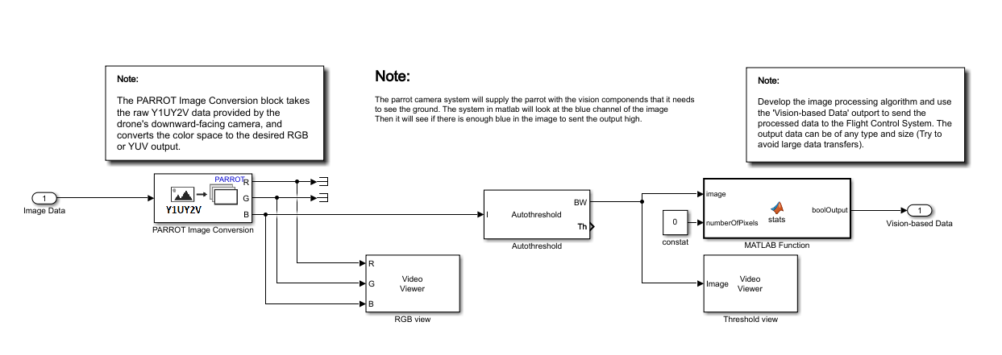

Figure 1 - Simulink vision

There are also two image monitors to monitor the output image of the drone. Also, to see if there is any blue in the image after the threshold block.

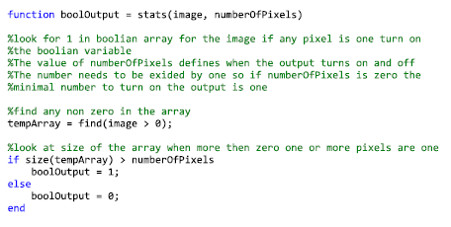

Figure 2 - Code of the simulation

The focus for this assignment is mainly on the simulation part. This is in an ideal environment. In the real world, there is no ideal environment, because the drone will see noise, false positives and negatives. This must be removed by opening, closing and dilatation.

# Goal of the project/ Project description

Goal of the project/ assignment should be clearly described.

* Provide enough background knowledge to understand the assignment
* The requirements of the assignment are clearly described with an overview of their relationships.
* The top level dynamic behaviour of a designed system should be clearly described in SysML use case diagram.
* The structure of the developed architecture should be clearly described using SysML BDD and IBD diagrams. The IBD must be drawn in System composer and BDD can be generated as a view.
* The dynamic behaviour of a subsystem within the envisioned architecture should be clearly described in either SysML statechart diagrams or Simulink StateFlow diagrams.
* The report provides an overview of the used software packages.
* Consistency between BDD and IBD (or other diagrams)

Technical details:

|  |
| --- |
| There is a well thought out and clearly described system architecture. (Is there technical substantiation and / or motivation). |
| Are the stakeholder of the system clearly identified and their interaction with system considered? |
| Did the team use functional decomposition to understand the requirements and to decompose the system into subsystems? |
| The team understand the correct use of Use Cases |
| The verification and validation of the developed architecture is considered. Some parts are already tested. |

# Conclusion

# Recommendations

# Reference list

# Certificates

Vivian Cheung – 3911721





Indra Erkens – xxstudentennummerxx-

Bart van Lent – 3886484

Wouter Mulder – 3786838



